**ME 111**

**Projection of Solids**

|  |  |  |
| --- | --- | --- |
| 1 | A cylinder 40 mm diameter and 50 mm axis is resting on one point of a base circle on VP while it’s axis makes 450 with VP and FV of the axis 350 with HP. Draw projections. | 30 |
| 2 | A pentagonal pyramid has height 60 mm and the side of a base 30 mm. The pyramid rests on one of its sides of the base on the H.P. such that the triangular face containing that side is perpendicular to the H.P. and makes an angle of 45 degree with the V.P. Draw its projections. | 35 |
| 3 | An equilateral triangular prism 20 mm side of base and 50 mm long rests with one of its shorter edges on HP such that the rectangular face containing the edge on which the prism rests is inclined at 300 to HP.  The edge on which prism rests is inclined at 600 to VP.  Draw its projections. | 35 |

**Solution**

**1**

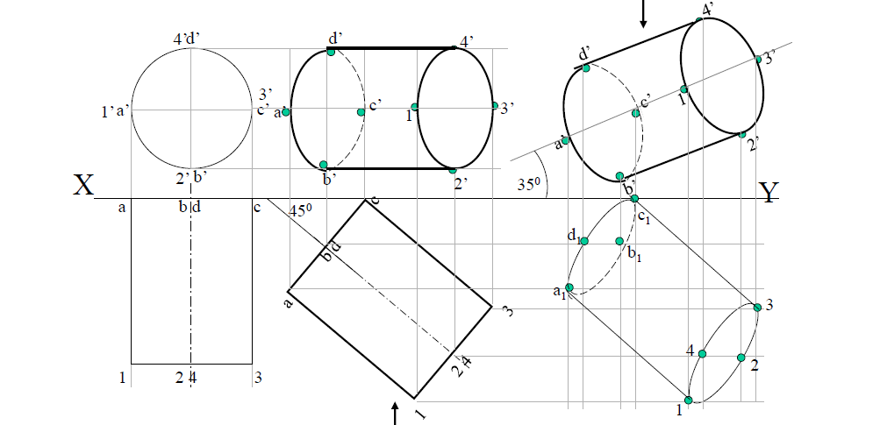

**2**

[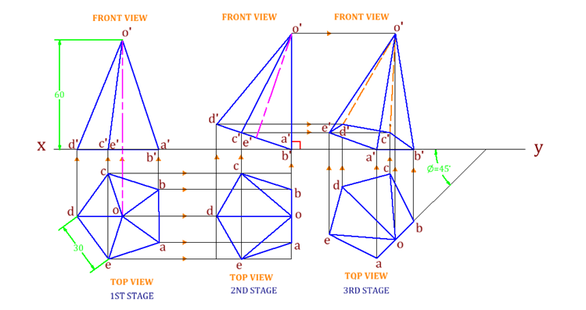](http://engineeringdrawing.org/wp-content/uploads/2012/04/Drawing6.1.png)

**3**

